BSI-lims Students Project implementation and configuration in react & node-js environment

Table of Contents

Downloding the project from git repo 3

Preparing to Lunch 5

Adding more tests to lims 8

deleting tests to lims 10

How to configure the project for local testing

# Downloding the project from git repo

If you do not have the git repo installed, you should follow next steps:

1. Open git
2. git clone https://bsistudents@bitbucket.org/bsistudents/master.git
3. Open the Project in File Explorer
4. Right Click and open them with Visual Studio Code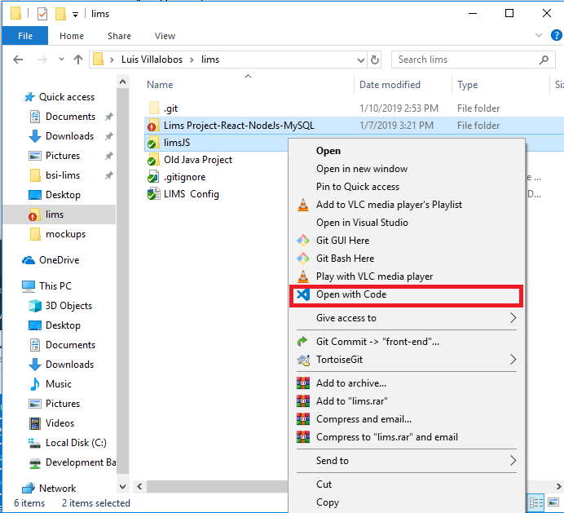
5. Make sure that you download the database as well and import it to your MySQL Manager of Choice (example, MyPHP Admin, MySQL Workbench). The file is in the Repo as well (\lims\limsJS\LIMS-BE\DBScript\Creation.sql)**.**

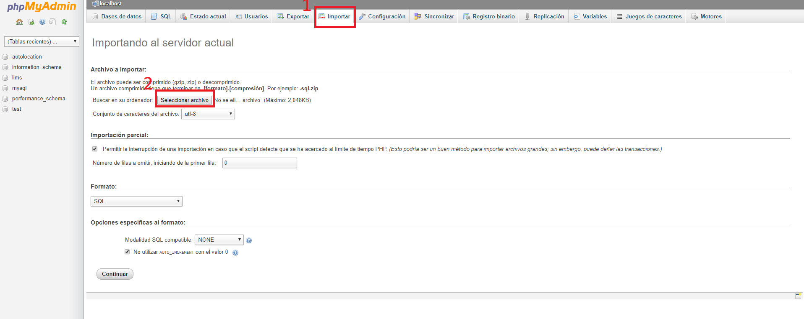

1. Once open navigate to Terminal->New Terminal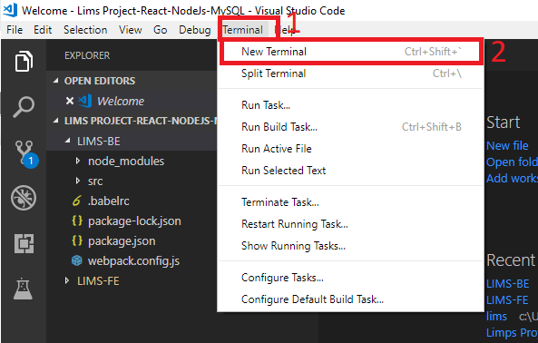

# Preparing to Lunch

1. To get started install React by opening the Terminal by selecting the LIMS-BE folder inside limsJS.

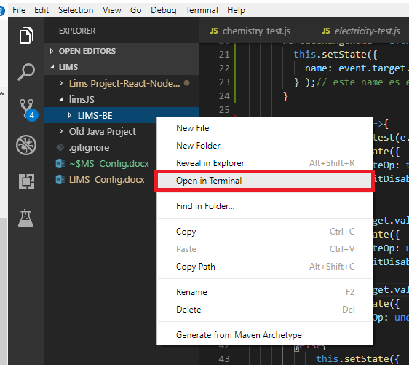

1. In order to run your React app we need to install some dependency, to do this you need to run “npm I React” and “nmp I axios” (in the LIMS-front directory).
2. Now in terminal get in the folder LIMS-Front, to lunch the React APP with the command “npm run start”.

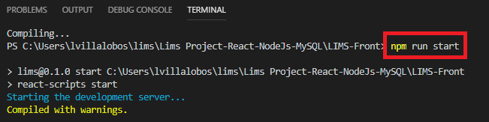

1. It will lunch the website in your “localhost:3000”, notice that the menu doesnt have any items attach to it that’s because we havent run the back-end of our application, to do the testing you need to manually type your current ip address to know your current ip address you can lunch the back-end application and in the terminal it will show it to you, follow the next step for this configuration.

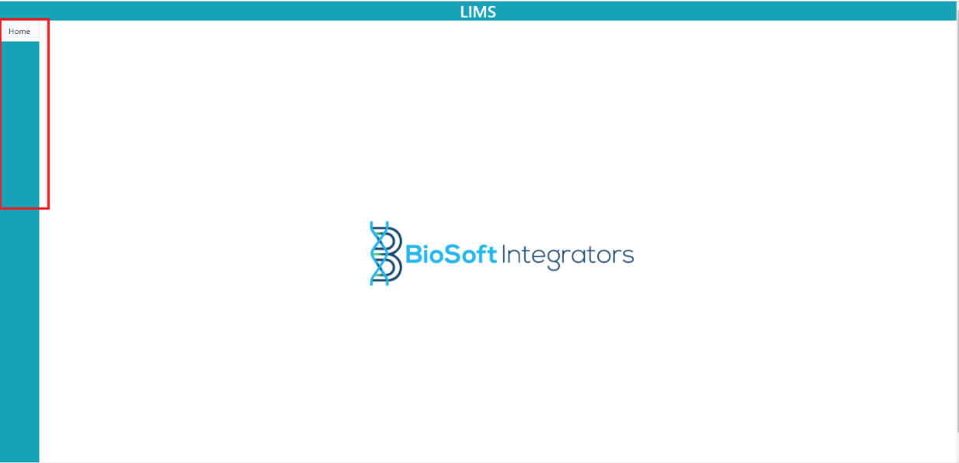

1. Open a new Terminal and get into the LIMS-BE that is our back-end application (step 7 ) followed by the next command “npc run dev” with this you will lunch the backend application.

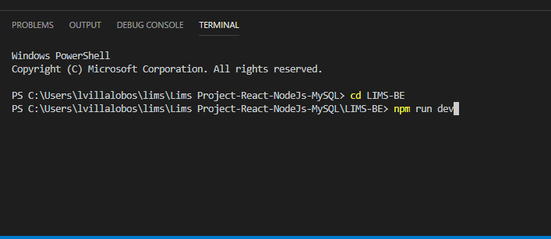

1. In this console you will notice that it gives you the ip that we need back in step 8, you can copy this ip so we can paste it in the configuration page.

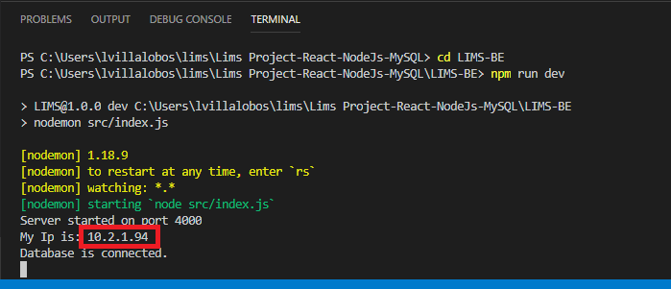

1. Open LIMS-FE -> src -> index.js

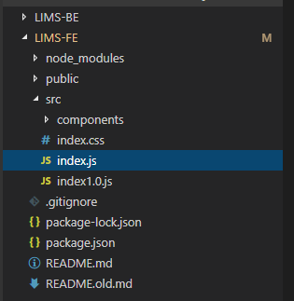

1. You can replace the ip here in line 23 with your own ip. 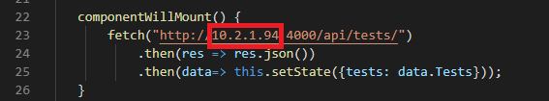
2. Now the server is running and the connection with the front end its established we can reload our page on local host:300 and notice the menu its updated.

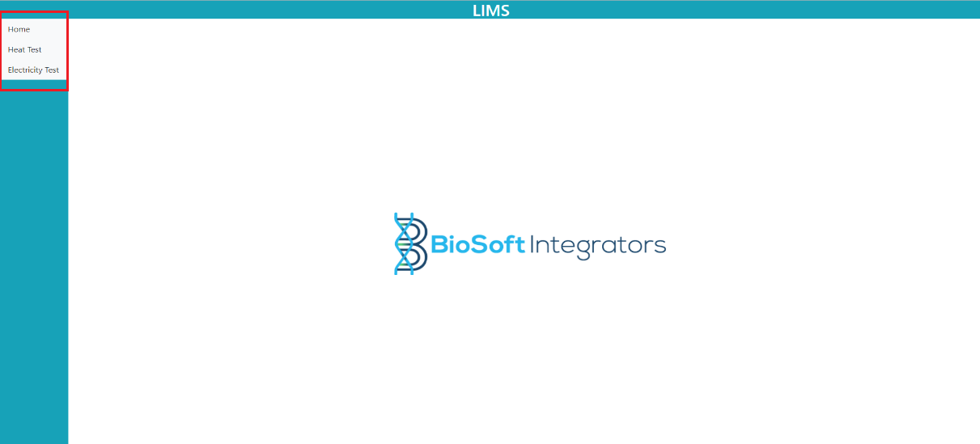

# Adding more tests to lims

The way its configured at the moment we have a debug screen in home that works for testing purposes in POST and GET, notes when handling this page is that “Name of the Test” can only be letters not numbers it has a two way validation if you manage to bypass the javascript validation in the front, the configuration by the controller server side will not make the POST and in terminal will send that no numbers are allowed.

For the “How many attributes” this field is intended for the dynamic way and it does not affect at this stage of development this will tell react how many components must render in each test (only int).

“Status” we are using 1 for active and 0 for inactive, this means that if a test is in 0 it will not show in the menu screen.

Remember to reload the page since its not yet programed correctly at this stage.